**Lab 4: OpenStreetMapping**

*Geog2011: Introduction to GIScience*

**Lab overview**

For this lab, you’ll be contributing data to OpenStreetMap for a community of your choosing. Over the last 15 years, OSM has become an impressively large database of geographic features throughout the world, but like many volunteer-driven projects, it still contains many notable gaps. For this project, you’ll be adding the outlines of at least **thirty** structures to this database.

As a student, you’ll learn how to add web-based basemap layers and download data from OpenStreetMap into QGIS. You’ll analyze gaps in the OSM dataset and get practice adding data to it.

**Lab structure**

This lab is broken up into the following parts:

* Adding a basemap to QGIS using the QuickMapServices plugin
* Downloading data from OpenStreetMap using QuickOSM and the Overpass API
* Filling in gaps in building data on OSM using the iD editor
* Viewing changesets for your area
* Downloading and mapping the updated dataset

Prior to starting this project, you should do two things. First, [sign up](https://www.openstreetmap.org/user/new) to be an OpenStreetMap contributor. Second, select the community you want to focus on for this project. It should be an area that is familiar to you and one that currently has incomplete building data. Browse through [OpenStreetMap](https://www.openstreetmap.org) to find the place you’d like to focus on.

**Procedures**

***Adding a basemap to QGIS using the QuickMapServices plugin***

Like many open source projects, QGIS has a number of user-designed extensions that improve the functionality. Adding any of these to QGIS can be done by clicking on Plugins on the menu bar and choose Manage and Install Plugins. Search for QuickMapServices from this menu, which gives you links to a number of publicly available basemaps. Click on the name of that service and click the install button (if it hasn’t already been installed by someone else).

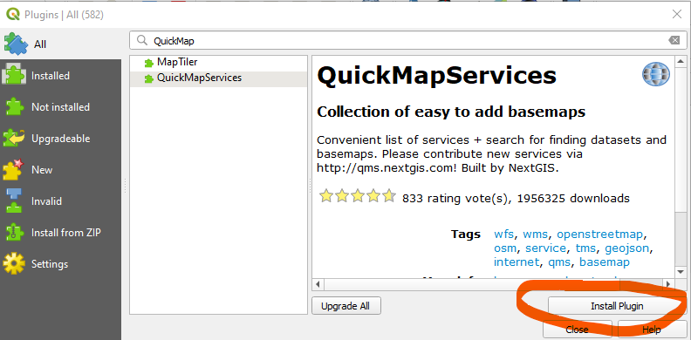

Once it’s installed, you’ll see these two new buttons on your toolbar:



The left link is a dropdown with several often used options. The right opens a box where you can search for specific layers. In the menu bar, you’ll also see a set of links for QuickMapServices by clicking on the “Web” heading. For now, use the left button above, choosing OSM > OSM Standard. You should now see a global map of OSM data on your map. Zoom into your community of interest.

* [Walkthrough video](https://www.youtube.com/watch?v=dTfCOlUxVbo) showing installation of QuickMapServices and basic usage

Most web basemaps are viewed best in the Web Mercator (or Pseudo-Mercator) projection, which is EPSG 3857. Change the projection of your map to that.

***Downloading data from OpenStreetMap using QuickOSM and the Overpass API***

The [Overpass API](https://wiki.openstreetmap.org/wiki/Overpass_API) provides a programmatic way for users to select and download data from the OpenStreetMap database. Within QGIS, the QuickOSM plugin uses this API to download data directly into QGIS. Install that plugin.

* [Video tutorial](https://www.youtube.com/watch?v=Yxkh2f-3Bj8) on how to use QuickOSM

You should now download all buildings that OSM has within your study area. Drawing on the video tutorial linked above, open the interface for QuickOSM and enter these parameters:

* Key: building
* Value: (blank)
* “In” dropdown: Change to “canvas extent”

Click on the “Run query” button once you’re done. New layers should show up on your map once you’ve finished. These may include points, lines, and polygons, but you’re only interested in the polygons.

Right click on the polygon layer and save it to your working folder so you don’t lose it when QGIS closes, as these are “scratch layers” that aren’t saved automatically. Save your map file as well.

Now let’s figure out where there are missing buildings. We can add a satellite imagery layer using QuickMapServices to do so. Click on the icon on the right below on your menu bar--the one with a magnifying glass.



A search box should show up in the lower right corner of the screen. Search for “Google Satellite Hybrid” and add it to the map. You will need to turn off the OSM base layer to see it.

Based on this imagery and the polygons you downloaded, identify 1-2 neighborhoods that are currently missing buildings. You’ll be focusing on them for your next step. (You also could have done this analysis directly in OpenStreetMap, but this process allows you to practice extracting data from OSM to your local computer.)

***Filling in gaps in building data on OSM using the iD editor***

Now you’re ready to add data to OSM. Log into the OSM website and zoom to your community of interest. Follow the steps in the linked video below to add at least **thirty** buildings to your community.

* [Tutorial on adding buildings to OSM](https://www.youtube.com/watch?v=E1YJV6I_rhY)

When you’ve finished and are about to save, you’ll see a screen that looks like this:

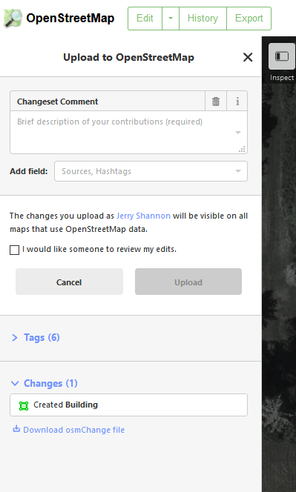

Notice that this lists how many buildings you created. You should also add a comment that summarizes the changes you made--“Added buildings to Main Street,” for example. Once you’re done adding buildings, take a screenshot of this page when you save to verify your contributions. If you add buildings in multiple sessions, just take a screenshot each time.

You can do more than 30 buildings! You can get up to **2 points extra credit**, 1 point for every additional 10 buildings up to 50.

***Viewing changesets for your area***

OpenStreetMap saves all contributions as “Changesets” and these are publicly visible. Zoom to the neighborhood you focused on and click on History on the top menu bar. You’ll see a list of contributions for the visible area on the left hand side, which should include your own.

* Video walkthrough: [Viewing OSM changesets](https://youtu.be/z-SrfpA1V4c)

Find a changeset for one other person working in your area and take a screenshot. Look through both what was added in this changeset and at information about the user who did the work.

***Downloading and mapping the updated dataset***

The OSM database should update within a minute or two once you have saved your data. Returning back to your QGIS map, download buildings for your community of interest again. Make sure that this layer is ***below*** your original layer, and style the data so your new additions are clearly visible.

Lastly, download features for **one** of the following Keys:

* Amenities
* Highways
* Leisure

You will likely see multiple geometries (points, lines, and/or polygons). Look at the attribute table for these features and find the field that gives a subcategory, which should be the same as the key value (e.g., “amenities” for the Amenities feature). Color at least one downloaded layer by those subcategories using the Symbology tab in Properties.

Take a screenshot of your final map, making sure that your new buildings and added features are clearly visible. This can just be an image of the QGIS screen--no need to use the Print Layout tool.

**Lab deliverables**

In a word document or via ELC, submit the following images:

* Screenshots of the “Upload to OpenStreetMap” screen (similar to what’s shown above) that indicates the number of buildings you have added.
* Screenshot of one other user’s changeset for contributions to the neighborhood you chose.
* Screenshot of your final map, which clearly shows the buildings you added and the additional feature you downloaded from OSM. If you did multiple neighborhoods, just create a screenshot for each one.

You’ll receive **15 points** for the buildings you digitized on OSM (0.5 points for each) and up to an additional 2 points for additional buildings. You’ll receive an additional **8** points for the screenshot showing your downloaded buildings and additional features.

In addition, answer the following questions.

1. (3 points) Assess the amount and quality of building data in your community of interest prior to the contributions you made. Approximately what percentage of the community was covered? If there were gaps, where were these located? Based on your knowledge of the community, why might any gaps exist? Or if no buildings were present, what other features were already mapped in this area?
2. (4 points) The [OpenStreetMap Wiki page for buildings](https://wiki.openstreetmap.org/wiki/Key:building) includes a list of building subtypes (or “values”). Based on what you know about the buildings you digitized, which values would be most appropriate for the building polygons you created and why?
3. (4 points) Open up the attribute table for the additional features you downloaded (the ones that are NOT buildings). Pick two columns that provide additional data for most of the features. Search the [OSM Wiki page showing all map features](https://wiki.openstreetmap.org/wiki/Map_features) for that feature to find a description for each of those columns--it may be listed under “additional attributes” at the bottom of the page--and summarise what each variable tells you. Alternatively, if the features have few columns, identify which two values for the features are most common (for example, apartments and houses for buildings) and describe them based on the wiki page.
4. (4 points) In a few sentences, explain what the changeset you included with your response tells you about what was added (streets, buildings, attributes, etc.) and who added it (# of edits, where they’ve added data, etc.).
5. (2 points) Summarise two things you learned during this assignment that felt valuable or interesting to you. What did you learn about user-contributed datasets or the ways we can access it?